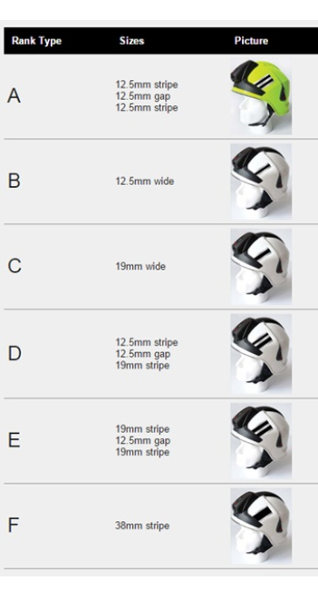

A = Crew Manager
B = Watch Manager
C = Station Manager
D = Group Manager
E = Area Manager
F = Brigade Manager

