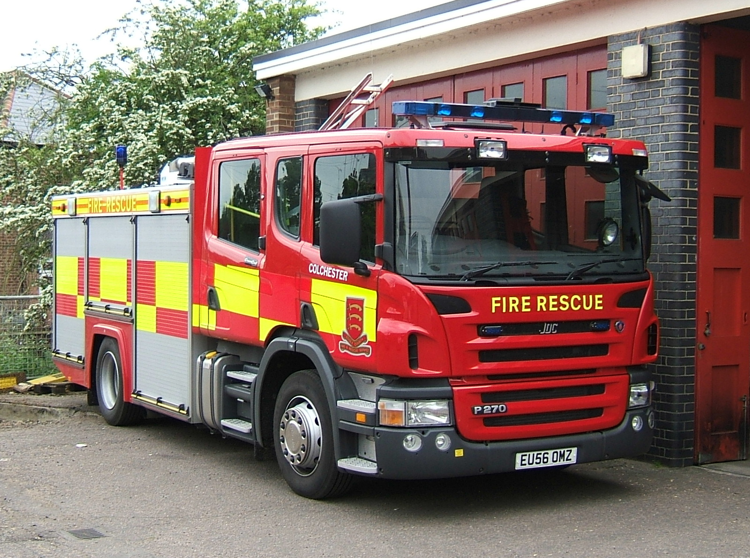
EMERGENCY RESPONSE DRIVER TRAINING

Evidence of competency portfolio

Candidate Name: -

Candidate Service number: -

Emergency Response Driving Competency and Training

Unit Summary

The focus of this unit is the development of a competent high speed driver. This
commences with establishing basic driving skills and progresses into high speed driving.
The aim of this unit is to ensure the student possesses the knowledge, understanding and
skills required to drive vehicles at high speed safely including whilst undertaking emergency
response. The student must be competent in vehicle preparation, the system of vehicle
control, driver attitude and health and safety. There is a requirement to demonstrate
competence in driving vehicles safely at speed on motorways and multi‐lane carriageways.
The Unit is based on the principles and systems covered by the police Road craft Manual,
and drivers should have a detailed knowledge of these.

Drivers will be required to drive in a style that minimises the risk of skidding and have the
ability and knowledge to apply corrective action when a skid occurs.
Those undertaking this Unit will hold a full DVLA licence for the class of vehicle to be driven.
This unit includes 5 elements:‐
HSDT 1.1 Demonstrate basic driving skills
HSDT 1.2 Prepare & drive vehicles at high speed
HSDT 1.3 Drive vehicles at high speed on motorways & multi‐lane carriageways
HSDT 1.4 Undertake an emergency response using a vehicle
HSDT 1.5 Avoid skids when driving an emergency vehicle

Links to Other Units
This is a stand alone unit.

Knowledge & Understanding
You need to know and understand the following:
1. Organisational policy and directives covering driving and emergency response
2. Relevant health and safety legislation, including dynamic risk assessment
3. Human aspects of emergency service driving.
4. The Highway Code.
5. The Road craft Manual
6. Road Traffic legislation
7. Manufacturers instructions
8. Motorway Procedures

Attitudes and behaviours
High Speed Training Quality Assurance | 5/6/2008 29
(To be demonstrated at all times when driving)
1. Give priority to public safety above the desire to attend the incident
2. Demonstrate a calm, considerate and professional manner.
3. Control the tendency to ‘personalise’.
4. Recognise and respond appropriately to the effects of fatigue, adrenaline, and stress
and other physical and physiological factors, which may impair judgement,
performance and decision making.
5. Concentrate on driving in the face of any other distractions.

Record of Assessment
ERDT ELEMENT 1.1 Demonstrate basic driving skills

NAME: |  | NUMBER: |  | INSTRUCTOR:
VEHICLE: |  | DATE: |  |  | DAY: | 1 | OF: | 9

Range statement: – A typical variety of road and traffic conditions within statutory speed limits.

Outcomes of effective performance | Feedback / Development |  | Achieved
 |  |  | Yes | No
- Complete basic vehicle checks, identifying, reporting and documenting obvious defects
2) Familiarise yourself with the vehicle controls before driving
3) Recognise, assess and manage hazards through effective observation, anticipation and planning
4) Steer the vehicle accurately to maintain a safe and appropriate course
5) Control the vehicle safely and accurately through the use of accelerator, brakes, gears and clutch as appropriate to the circumstances
6) Make progress appropriate to the conditions and circumstances
7) Approach and negotiate corners safely
8) Position the vehicle safely as appropriate to the circumstances
9) Use appropriate signals and respond correctly to the signals of other road users
10) Select safe and appropriate locations to park and manoeuvre the vehicle

11) Call on the assistance of others before completing difficult manoeuvres

12) Reverse, manoeuvre and park the vehicle safely

COMPETENCY ACHIEVED
INSTRUCTOR SIGN |  | CANDIDATE SIGN:

Record of Assessment
ERDT ELEMENT 1.2a Prepare the vehicle to drive at high speed

NAME: |  | NUMBER: |  | INSTRUCTOR:
VEHICLE: |  | DATE: |  |  | DAY: | 2 | OF: | 9

Outcomes of effective performance |  | Feedback / Development |  | Achieved
 |  |  |  | Yes | No
Preparing the vehicle
1) Ensure you are authorised to prepare and drive the vehicle
2) Familiarise yourself with the vehicle and its controls
3) carry out required checks to;

Tyres
Brakes
Fluid levels
Lights
Sound equipment
Safety equipment
Bodywork
Cleanliness
Operational equipment
4) ensure the vehicle is fit for purpose during and after use
5) identify, report and record any defects or damage prior and following use, and take the correct action in regard to these
6) ensure that any equipment required to be with the vehicle is present and in working order
7) Keep accurate and complete documentation as required relating to your use of the vehicle.
COMPETENCY ACHIEVED
INSTRUCTOR SIGN |  |  | CANDIDATE SIGN:

Record of Assessment
ERDT ELEMENT 1.2b Driving the vehicle at high speed

NAME: |  | NUMBER: |  | INSTRUCTOR
VEHICLE: |  | DATE: |  |  | DAY: |  | OF: | 9

SPEED |  | LOCATION |  |  |  | SURFACE |  | TRAFFIC |  | VISIBILITY
In excess of limit |  | Major Roads |  | Urban |  | Good |  | Low |  | Good
In excess of flow |  | Minor Roads |  | Rural |  | Poor |  | High |  | Poor

Outcomes of effective performance | Feedback / Development |  | Achieved
 |  |  | Yes | No
A) Formulating and implementing driving plans
1) Gather information at an early stage early stage through accurate observations and the use of other senses
2) use this information to correctly anticipate all driving situations

3) use observation links effectively

4) use information and anticipation to formulate flexible driving plans

5) implement driving plans to safely negotiate all driving situations

B) Making progress whilst showing restraint
1) accurately judge the speed of your own and other vehicles relative to your proposed actions and the circumstances
2) make progress whilst maintaining the need for restraint and safety

C) Controlling the vehicle

1) control the vehicle safely and smoothly through use of the accelerator

2) control the vehicle safely and smoothly by applying the required amount of braking at the correct time

3) when driving manual vehicle select the correct gear for the circumstances by smooth use of the gears and clutch

4) steer the vehicle accurately, adapting steering techniques as necessary when manoeuvring

INSTRUCTOR SIGN |  | CANDIDATE SIGN:

Record of assessment
ERDT ELEMENT 1.2b Driving the vehicle at high speed (continued)

NAME: |  | NUMBER: |  | DATE:

Outcomes of effective performance | Feedback / Development |  | Achieved
 |  |  | Yes | No
D) Positioning
1) position the vehicle correctly when following and overtaking other vehicles

2) position the vehicle correctly when negotiating corners and bends

3) position the vehicle to obtain the best view with regard to safety

4) adopt the safest road position at all times in relation to existing road and traffic positions

E) Cornering

1) assess corners and bends correctly and accurately
2) negotiate corners and bends taking account of all relevant factors

F) Making and interpreting signals

1) Make appropriate signals to other road users using indicators, lights, audible, and hand signals.

2) correctly interpret and act on signals from other road users

G) Overtaking

1) identify, plan and execute all overtaking manoeuvres safely when passing stationary and moving objects
2) apply the correct degree of restraint at all times

COMPETENCY ACHIEVED
INSTRUCTOR SIGN |  | CANDIDATE SIGN:

Record of Assessment
ERDT ELEMENT 1.3 Drive vehicles at high speed on motorway
and multi-lane carriageways

NAME: |  | NUMBER: |  | INSTRUCTOR: |  | Antony Mead
VEHICLE: |  | DATE: |  |  | DAY: |  | OF: | 9

SPEED |  | LOCATION |  | Multi Lane |  | SURFACE |  | TRAFFIC |  | VISIBILITY
In excess of limit |  | Day |  | Urban |  | Good |  | Low |  | Good
In excess of flow |  | Night |  | Rural |  | Poor |  | High |  | Poor

Outcomes of effective performance | Feedback / Development |  | Achieved
 |  |  | Yes | No
1) Follow the correct procedure for joining motorway / multi carriageway road

2) Adopt the correct lane or position for existing road and traffic conditions

3) adjust speed appropriately for type of road and traffic conditions

4) follow the correct procedure for exiting the motorway / multi carriageway road

5) understand the relevant sections of the highway code, including the meaning of all road signs, matrix signals, marker boards and cats eyes

COMPETENCY ACHIEVED
INSTRUCTOR SIGN |  | CANDIDATE SIGN:

Record of Assessment
ERDT ELEMENT 1.4 Undertake an emergency response drive

NAME: |  | NUMBER: |  | INSTRUCTOR:
VEHICLE: |  | DATE: |  |  | DAY: |  | OF: | 9

SPEED |  | LOCATION |  | Multi Lane |  | SURFACE |  | TRAFFIC |  | VISIBILITY
In excess of limit |  | Day |  | Urban |  | Good |  | Low |  | Good
In excess of flow |  | Night |  | Rural |  | Poor |  | High |  | Poor

Outcomes of effective performance | Feedback / Development |  | Achieved
 |  |  | Yes | No
1) Ensure that an emergency response is justifiable and should be maintained
2) Ensure that there is justification for taking advantage of your speed exemptions

3) make effective use of emergency warning equipment, when appropriate

4) Anticipate and respond to the action of other road users when emergency warning equipment is used

5) make safe and appropriate progress

6) maintain clear communication with others as required

7) maintain duty of care whilst using legal exemptions

8) ensure all actions are consistent with legal requirements and organisational policies
COMPETENCY ACHIEVED
INSTRUCTOR SIGN |  | CANDIDATE SIGN:

Record of Assessment
ERDT ELEMENT 1.5 Avoid and correct skids when driving
an emergency vehicle

NAME: |  | NUMBER: |  | INSTRUCTOR:
VEHICLE: |  | DATE: |  |  | DAY: |  | OF: | 9

TYPES OF SKID |  |  |  | VEHICLES
Front wheel |  | Four wheel |  | Without active safety devices
Rear wheel |  |  |  | With active safety devices

Outcomes of effective performance | Feedback / Development |  | Achieved
 |  |  | Yes | No
1) Identify the causation and types of skids

2) Drive the vehicle in a manner, which minimises the risk of skidding

3) Understand appropriate corrective action on the type of vehicle being driven

COMPETENCY ACHIEVED
INSTRUCTOR SIGN |  | CANDIDATE SIGN:

Record of Assessment
ERDT UNIT 1
Attitudes and Behaviours are assessed over the whole unit

NAME: |  | NUMBER: |  | INSTRUCTOR:
VEHICLE: |  | DATE: |  |  | DAY: |  | OF: | 9

Attitudes and behaviours | Feedback / Development |  | Achieved
 |  |  | Yes | No
- Give priority to public safety

2) Demonstrate a calm, considerate and professional manner

3)Control the tendency to personalise

4) Recognise and respond appropriately to the effects of fatigue, adrenaline, stress and other physical and physiological factors, which may impair judgment, performance and decision making
5) concentrate on driving in the face of any other distractions

COMPETENCY ACHIEVED

INSTRUCTOR SIGN |  | CANDIDATE SIGN:

Record of Assessment
ERDT UNIT 1
Knowledge and understanding are assessed over the whole unit

NAME: | Hepworth | NUMBER: | 33372 | INSTRUCTOR: |  | Antony Mead
VEHICLE: | EU59 GGV | DATE: | 23/04/19 – 03/05/19 |  | DAY: | 1-9 | OF: | 9

Knowledge and understanding | Feedback / Development |  | Achieved
 |  |  | Yes | No
- Organisational policy and directives covering driving and emergency response.

2) Relevant health and safety legislation, including dynamic risk assessment

3) Human aspects of emergency service driving.

4) The Highway Code.
5) The Road craft Manual
6) Road Traffic legislation.

7) Manufacturers instructions

8) Motorway Procedures

COMPETENCY ACHIEVED

INSTRUCTOR SIGN |  | CANDIDATE SIGN:

