ECFRS ICT DEPARTMENT Business Plan 2018 to 2020

1. Vision, Purpose and Alignment

1.1 The Vision of the Service

Essex is a safer place to live, work and travel.

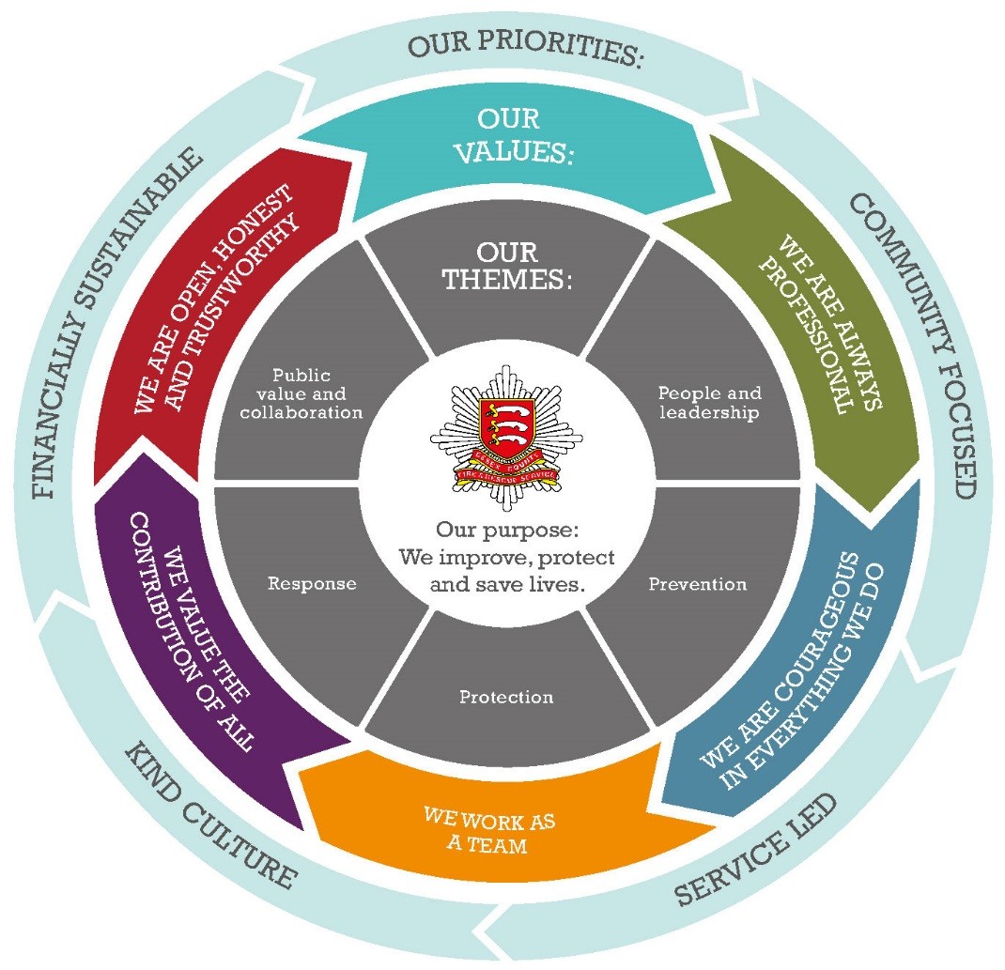

1.2 Vision

“Working with ECFRS to become more efficient and effective in delivering an ever safer Essex:
    - by making life easier for customers through the provision of reliable ICT systems
    - whilst enabling cost effective future technology investments
    - being the responsible gateway to technical innovation and development”

1.4 Purpose

The purpose of this plan is to inform managers and employees of the aims and objectives of the ECFRS ICT Department to support the Service Strategy and the achievement of the Service’s objectives:
- Prevention, Protection and Response
- Improve Safety on Roads
- Help the Vulnerable to Stay Safe
- Promote a Positive Culture in the Workplace
- Develop and Broaden the Roles and Range of Activities Undertaken by the Service
- Be transparent, open and accessible
- Collaborate with our Partners
- Make Best use of Resources

1.5 Corporate Risks

Corporate Risks undertaken by the ICT Dept contribute to the mitigation of;
- Loss of Information Confidentiality
- Loss of Information Availability
- Failure to Deliver ICT services in a Business Continuity Event

1.6 Core Business

We have a statutory responsibility to reduce (prevent) incidents occurring, to protect people and property and to respond to emergencies when they do happen

1.7 Governance arrangements

Financial Governance where projects greater than 250K require Fire Authority approval prior to commencement. All change projects are tracked in a separate cost code (9506) and reported and reviewed monthly with Finance.

Project Governance is through the Change Board where projects will not commence until they obtain project approval. Progress through stage boundaries is approved through the Change Board. Projects are managed using the PRINCE2 framework. There are regular project board meetings that IOCT attend.

There are Monthly ICT Management Meetings at which key issues regarding change and business as usual are discussed.

There is a controlling framework comprising of the ICT Strategy and “Technology Bricks” which documents the current product set and applications used by Service and their position in the lifecycle of investigate, develop, exploit, contain and retire. Products are moved through this lifecycle by agreement with the Design Authority Team which meets on a monthly basis.

Department Structure

1.9 Meeting Structure

Frequency | Conducted By | Attended By | Description | Purpose
DAILY
Daily Stand Up Meetings | Technical Support Manager | Infrastructure, Applications, Network & Security Teams along with Service Desk | Various Interaction/Collaboration between department teams | To establish what is being worked on, any issues/solutions. Also set priorities for the day.
WEEKLY
CAB – Change Advisory Board | Change Manager | Service Delivery Teams | To present and approve/decline all changes that have not been pre-approved | Essential Change Management governance which has the intention of reducing change related incidents
Service Delivery Management Meeting | Service Delivery Manager | Service Delivery Manager, IT Technical Support Manager, Service Desk Manager | Weekly meeting held with Senior Management Team | To look at all areas within Service Delivery and plan/discuss all relevant issues
FORTNIGHTLY
MONTHLY
ICT Team Meeting | Service Delivery Manager | ICT Department | To inform the ICT Team of organisational information and to provide an open forum for the team. | Information filtered down from SLT and Manager’s Briefing and opportunity for team to discuss any issues they may have
1:1 | Service Delivery Manager & All Managers | All Their Team Members | To track progress of agreed objectives and personal development. | Personal meeting to review objectives
Monthly to Annual | Various | Suppliers | Reviews with significant external suppliers held on various frequencies dependent on the value and importance to the Service | To discuss current service regarding SLA’s
DESIGN AUTHORITY MEETING | Service Delivery Manager | Service Delivery Manager, Head of ICT, Technical Architect, Security & Governance Manager, | Monthly meeting to discuss and changes to technology requirements | To discuss proposed changes to our technology bricks.
Problem Meeting | Problem Manager | Service Delivery Team | Monthly meeting to discuss underlying problems | To move problems forward and resolve or find work arounds

1.10 National and Regional meetings attended

Frequency | Description | Purpose
MONTHLY
ESSEX ON_LINE PARTNERSHIP |  | Forum to share knowledge and best practice within the public sector within Essex.
QUARTERLY
CFOA ICT Management Meeting |  | Enable information sharing and lessons learned across the UK & Fire and Rescue Service.
Bi Annually
NFCC IT managers Meeting |  | Enable information sharing, lessons learned and collaboration across the UK & Fire and Rescue Service.

1.11 Relevant Legislation

- DATA PROTECTION ACT (2018)
- GENERAL DATA PROTECTION REGULATION (EU) 2016/679
- PUBLIC SECTOR PROCUREMENT REGULATIONS

1.12 Policy and Guidance Responsibilities

ICT Acceptable Use Policy
ICT Contracts Management
Major Incident Handbook
MTPAS Policy
Security Policy
Secondary Mobilising Policy

1.13 Information Assets
See separate Information Asset Register
Various Managers appointed depending on the asset.

1.14 Defined processes

New Starter Process
Leaver Process
Changes/Promotion/Acting up Process
Allocation of ICT equipment to Role process
ICT Change Process
Problem Management Process

ICT Department Operational Action Plan

Technology Area | April 19 | May 19 | June 19 | July 19 | Aug 19 | Sept 19 | Oct 19 | Dec 19 | Jan 20 | Feb 20 | Mar 20 | Apr 20
Desktop | POC Desktop replacement 25% | POC Desktop replacement 50% | POC Desktop replacement 100% | Desktop replacement test 100% | Desktop Hardware server build  100% | Desktop Hardware begin rollout 30% | Desktop Hardware complete rollout 60% | Desktop Hardware complete rollout 100%
SAN |  |  | SAN Replacement 10% | SAN Replacement 30% | SAN Replacement 100%
Appraisals | Appraisals 20% | Appraisals 95% | Appraisals 100% Complete
Skype for Business |  |  |  | Skype for Business Upgrade 100%
Printer Replacement |  |  | Printer replacement 10% | Printer replacement 20% | Printer replacement 40% | Printer Replacement  80% | Printer Replacement 100%
Tranman V9 |  |  |  |  |  |  | 30%
ICT System Maintenance (Ongoing) | Desktop Maintenance 20% | Desktop Maintenance 20% | Desktop Maintenance 20% | Desktop Maint 20% | Desktop Maint 20% | Desktop Maintenance 20% | Desktop Maint 20% | Desktop Maintenance 20% | Desktop Maint 20% | Desktop Maint 20% | Desktop Maint 20% | Desktop Maint 20%
ICT System Patching (Ongoing) | Patching 10% | Patching 10% | Patching 10% | Patching 10% | Patching 10% | Patching 10% | Patching 10% | Patching 10% | Patching 10% | Patching 10% | Patching 10% | Patching 10%

ICT Service Desk Action Plan

Dept Ob | Action | Owner/ Delivery | Timescale | Outcome(s) | Success Measure(s) | Budget/Resources
1.1 | Service Desk Stabilisation | Service Desk Manager | Q3 2019 | 1st and 2nd line service desk team in place | Staff in place Q1  Staff retention Q3 | ICT Service Desk Team
1.2 | Hours of cover to be reviewed | Service Desk Manager | Q1 2019 | All avenues into service desk reviewed and business feedback analysed for any additional requirements. Peak support hours established. | Based on analysis and feedback on operational support requirements, if applicable action plan sign off for recommended support structure. | ICT Service Desk Team
1.3 | Internal Cherwell Incident and Service request processes to be reviewed | Service Desk Manager | Q3 2019 | Improved productivity through effective processes | Repeatable consistent processes followed with a reduction in service request fulfilment | ICT Service Desk Team
1.4 | External process review, interfaces with HR systems | Service Desk Manager | Q4 2019 | Automated as far as possible processes for starters and leavers | Repeatable consistent processes followed with a reduction in service request fulfilment | ICT Service Desk Team

Service Desk Action Plan

Dept. Ob | Action | Owner/ Delivery | Timescale | Outcome(s) | Success Measure(s) | Budget/Resources
2.1 | Review Cherwell OLA’s with regards to response and resolution times | Service Desk Manager | Q2 2019 | Introduction of effective OLA’s between 1st and 2nd line support teams | Improved SLA achievement for incidents and service requests.
2.2 | Categorisation of incidents and service requests | Service Desk Manager | Q1 2019 | Review of categories in Cherwell | Nil reporting on Other | Service Desk Manager

Asset Action Plan

Dept. Ob |  | Action |  | Owner/ Delivery |  | Timescale | Outcome(s) |  |  | Success Measure(s) |  | Budget/Resources
3.1 |  | Map out process for asset management with each of the stake holders |  | Tech Support Manager/ Contracts and assets officer |  | Q4 2018 | Fully mapped asset management process |  |  | Process will define asset management system |  | Tech Support Manager/ Contracts and assets officer
3.2 |  | Define ITSM improvements to support the asset management process |  | Tech Support Manager |  | Q4 2018 | Defined plan of action for development work |  |  | ITSM requirements meet the mapped process plan |  | Tech Support Manager/ Contracts and assets officer
3.3 |  | Source of truth established for all assets |  | Tech Support Manager/ Contracts and assets officer |  | Q3 2019 | Single database of asset management information |  |  | Accurate asset information |  | Tech Support Manager/ Contracts and assets officer
3.4 |  | Cherwell development phase 1 |  | Tech Support Manager |  | Q1 2019 | Refined CMDB |  |  | Accurate asset information |  | Tech Support Manager
3.5 |  | Complete user guides and training sessions |  | Contracts and assets officer |  | Q3 2019 | Repeatable processes |  |  | Accurate asset information recorded |  | Contracts and assets officer
3.7 | Cherwell development phase 2 |  | Tech Support Manager |  | Q1 2020 |  |  | Efficient SM Toolset | Reduction in manual overhead |  | Tech Support Manager

End of life action plan

Dept. Ob | Action |  | Owner/ Delivery |  | Timescale | Outcome(s) | Success Measure(s) | Budget/Resources
4.1 | Identify all EOL systems | Service Delivery Manager |  | Q4 2018 |  | Decision paper | Management agreement to proceed with external consultancy | Service Delivery Manager/ Tech support manager
4.2 | Procurement of consultancy resource | Contracts and assets officer |  | Q1 2019 |  | Detail onto path of next phase of procurement | Consultant engaged to carry out piece of work by end of Q1 2019 | Contracts and assets officer
4.3 | Dependency mapping | Service Delivery Manager |  | Q1 2019 |  | Accurate assessment of mapped EOL systems | No failed changes as a result of retiring services | Service Delivery Manager/Tech support manager
4.4 | SAN Storage renewal | Service Delivery Manager |  | Q4 2018 |  | Extension of Maintenance contract | Contract in place | Contracts and assets officer
4.5 | EOL Systems short term remediation | Service Delivery Manager |  | Q4 2019 |  | Series of measures in the event of failed EOL system | Replacement of failed equipment to maintain service provision. | Service support team

Disaster Recovery Plan
Dept. Ob | Action | Owner/ Delivery | Timescale | Outcome(s) | Success Measure(s) | Budget/Resources
5.1 | Identification of critical Systems | Service Delivery | Q4 2018 | List of Services required in the event of DR | Formulation of DR plan | Service Support
5.2 | Rationalise the requirement of DR | Service Delivery | Q1 2019 (March) | Understand dependencies and current architecture | Available DR systems to support critical services | Service Support
5.3 | Implement required changes to support DR exercise | Service Delivery | Q1 2019 | DR environment that meets DR plan | Defined DR process | Service Support
5.4 | Carryout DR exercise | Service Delivery | Q4 2019 | DR Exercise | Successful DR exercise and subsequent failback | Service Support

Licensing and Compliance

Dept. Ob |  | Action |  | Owner/ Delivery | Timescale |  | Outcome(s) |  | Success Measure(s) |  | Budget/Resources
6.1 |  | Identify the types of licenses |  | Contracts and assets officer | Q1 2019 |  | All Licenses are identified and rationalised |  | Reduction in overall licenses |  | Service Support
6.2 |  | Document how the licenses work/are used |  | Contracts and assets officer | Q3 2019 |  | Individual/Concurrent? |  | Reduction in cost of licenses through elimination of un needed licenses |  | Service Support
6.3 |  | Establish a process for each license and how they are maintained |  | Contracts and assets officer | Q4 2019 |  | All licenses will be renewed |  | Unavailability of systems reduced |  | Service Support
6.4 |  | Identify the supplier of the licenses |  | Contracts and assets officer | Q1 2019 |  | All suppliers detailed in Cherwell |  | Fully completed CMDB |  | Service Support
6.5 |  | Identify Primary Users |  | Contracts and assets officer | Q3 2019 |  | All license owners are identified |  | Reduction in use of licenses |  | Service Support
6.6 | Repopulate System with up to date information |  | Contracts and assets officer |  | Q3 2019 | Duplicates and discrepancies removed |  | Accurate CMDB |  | Service Support

3.1 Service Area Performance

- IT Service Management System
- Monthly Stats produced to detail incidents, priorities and how long to resolve, this is monitored by the Service Delivery Manager
- Monthly exception reporting to identify aged incidents and service requests

4. Training and Development

Working Safely Course completed by 95% of the Team.

 | Skill/Course | Audience | Method | Int/Ext | Frequency
 | ITIL V4Foundation Course | All ICT Personnel | Classroom Based & Exam | External | Once
 | ITIL V3 Practitioner Course | ICT Department | Classroom Based & Exam | External | Once
 | Service Desk Institute – Basic & Supervisor | Service Desk Technicians | Classroom Based | External | Once
 | Service Desk Institute - Manager | Service Desk Manager | Classroom Based | External | Once
 | ITIL Expert | Service Delivery Manager, | Classroom Based | External | Once
 | Prince 2 Foundation | Service Delivery Manager, Technical Support Manager. | Classroom Based | External | Once
 | PRINCE 2 PRACTITIONER | Service Delivery Manager, Technical Support Manager. | Classroom Based | External | Once every 3 years
 | MCSA - Microsoft Certified Solution Associate | All 2nd line staff with specialisms for each of their areas | Classroom Based | External | Once
 | Microsoft MCSE – Microsoft Certified Solutions Expert | All senior 2nd line staff with specialisms for each of their areas | Classroom Based | External | Once

5. Local Performance Indicators for 2019/20

Service Area | Activity | Success Measure(s) | Target | Information Source
ICT BAU Budget Control | Budget Management | Budge effectively used throughout the financial year | Deliver services within budget | Monthly financial reports
ICT Service Delivery | ICT Incidents | Monthly Stats produced to detail incidents, priorities and how long to resolve, this is monitored by the Service Delivery Manager  Monthly exception reporting to detail aged calls and steps required to resolve. | Priority 1 Incidents responded to immediately  Priority 2 Incidents responded to and resolved within SLA  Priority 3 Incidents responded to and resolved within SLA  Priority 4 incidents responded to and resolved within SLA | IT Service Management System

6. Document Information

This version no.
Date edited | 06/06/2019
Status | Draft
Author(s) | Martin Chester
Reviewer(s)
Approver(s)
File location | SharePoint>ICT Management Team>ICT Business Planning 2018-2019>Business Plan 2018 to 2020

Please Note:

The 2018–2020 business plans is made up of four key components:

Section | Format/Scope | Contact for Assistance
1. Business Plan | Word document (one per dept/directorate) | Tracy King ext 6252
2. Risk register | JCAD entry (one per department) | Charles Thomas ext 6376
3. Budget forecast | Excel workbook (one per cost centre) | Glenn McGuinness ext 6186  Jayesh Padania ext 6086  Elaine Hodgson ext 6187  Simon Nobbs ext 6190  Paula Drane ext 6189
4. Staff headcount forecast | Excel workbook (one per cost centre)

